# C3- S8 PRACTICE

# Flowchart to Boolean expression

Example

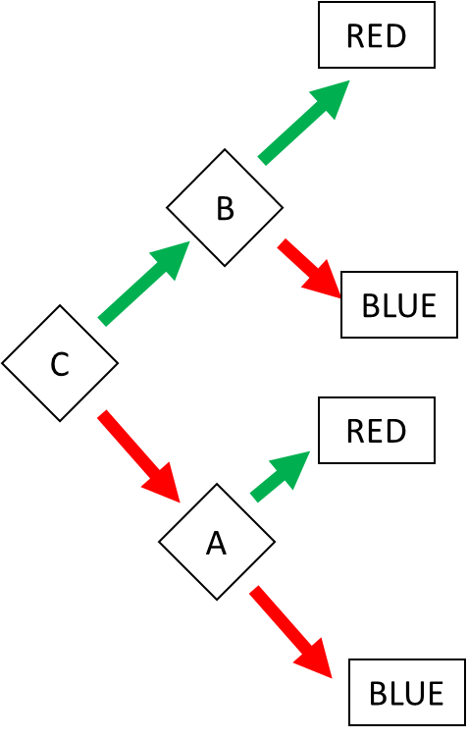

Answer:

RED = (C and B) or (!C and A)

BLUE = (C and !B) or (!C and !A)

# Ex 1: Find the Boolean expression of BLUE

BLUE = (A and !B) or (A and B and !C) or !A and !D and B

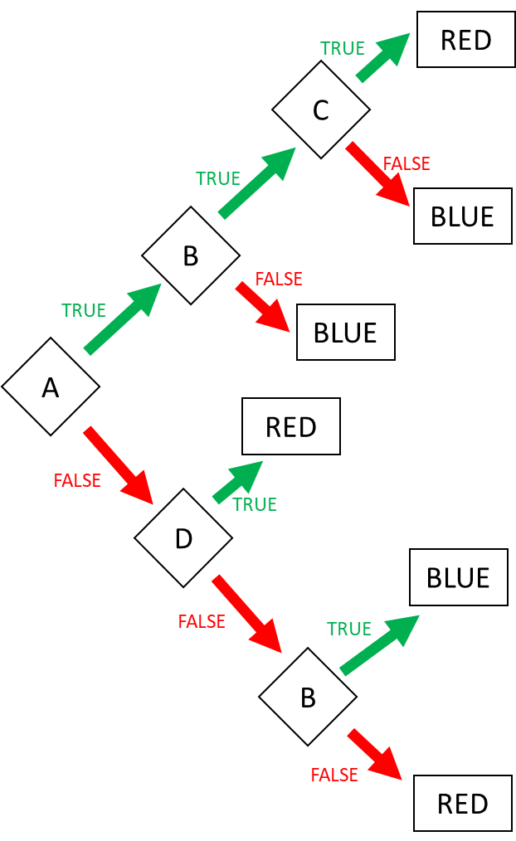

# Ex 2: Find the Boolean expression of BLUE

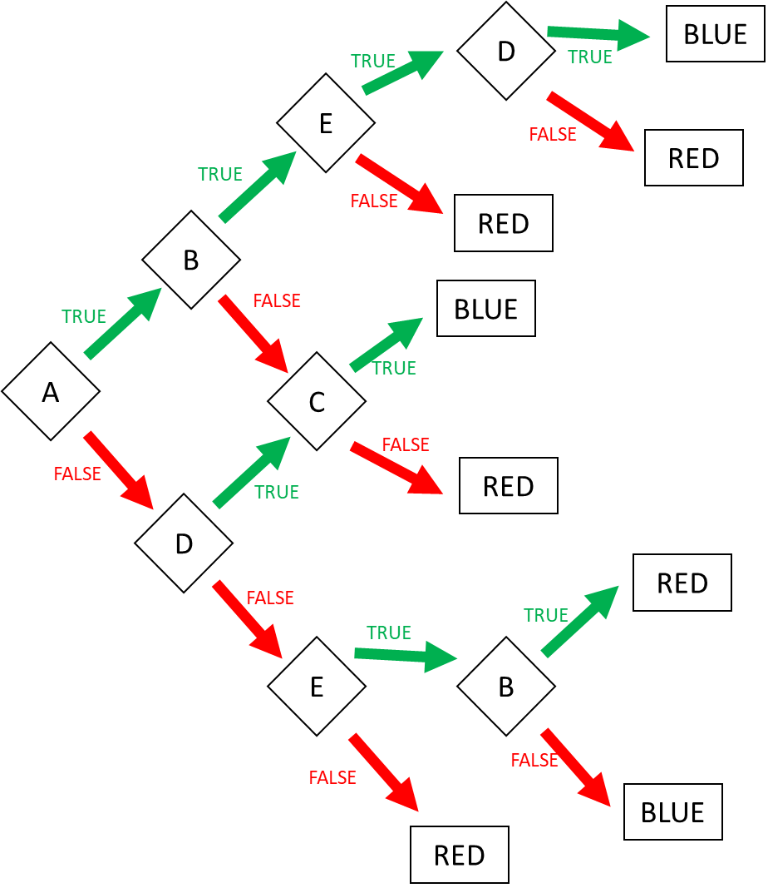

BLUE = (A and B and E and D ) or (A and !B and C) or (!A and D and C) or (!A and !D and E and !B)

Ex 2: Create the flowchart according to the expressions (4 flowcharts):

1. Go to the market = AB or !A!C
2. Go to swim = ( Sunny AND Sunday) OR ( !(Sunny) and Monday and no homework)
3. I’m superman = A!BCD or AB!CD or !ABCD
4. Happy = ABC!DE!F or A!BCD!EF or !ABCD!E or !A!BC
   1. Go to the market

T

Can go

T

B

F

Can’t go

A

F F

Can go

C

T

Can’t go

* 1. Go to swim = ( Sunny AND Sunday) OR ( !(Sunny) and Monday and no homework)

Can go

T

sunday

T

Can’t go

F

Sunny

T T

Can go

No homework

F F

Can’t go

Monday

Can’t go

F

* 1. I’m superman = A!BCD or AB!CD or !ABCD

nothing

C

F T

T

D

B

T F

superman

T

C

A

F

C

T

B

F F

Nothing

A!BCD

AB!CD

!ABCD

* 1. Happy = ABC!DE!F or A!BCD!EF or !ABCD!E or !A!BC

D

F

C

Happy

E

B

C

A

B

F

E

D

Happy

C

Happy

# 1D range colors

Example:

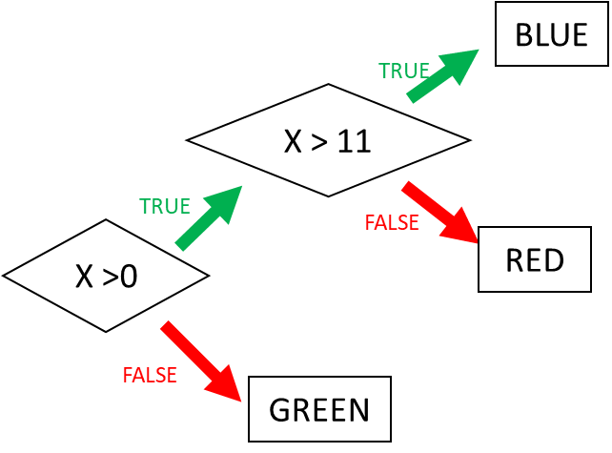

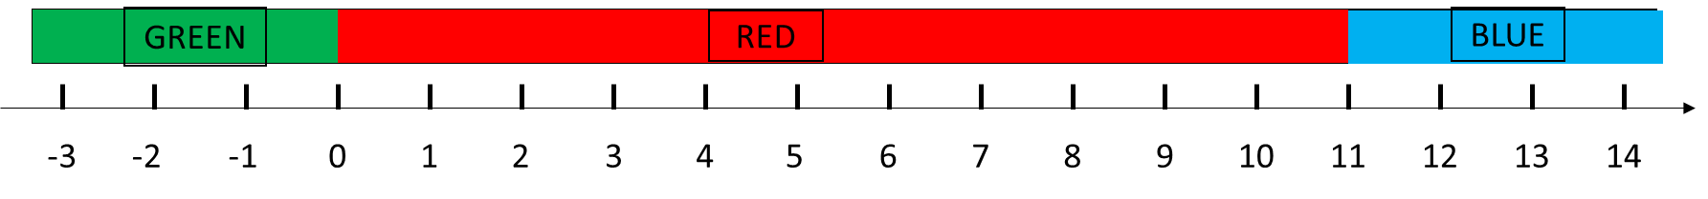

Ex 3: Ranges (1)

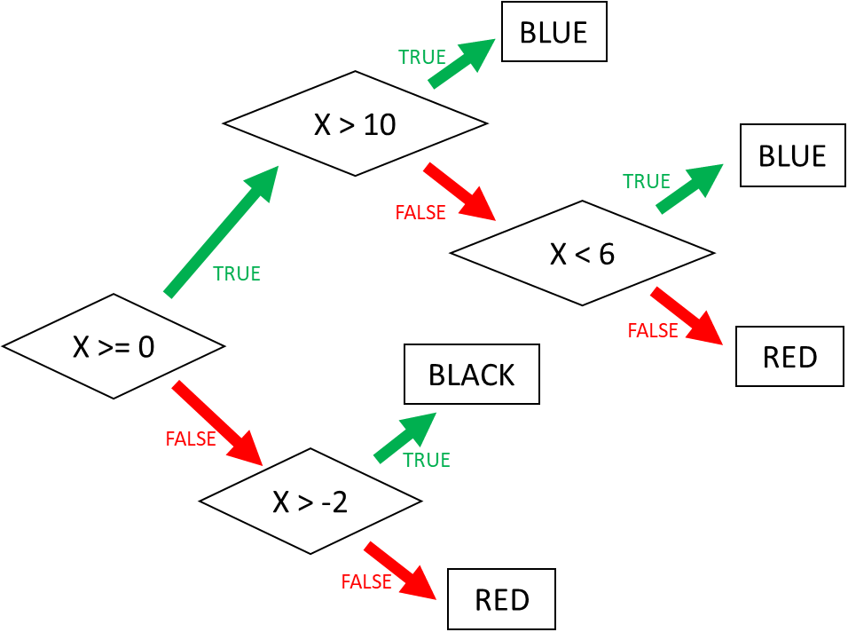

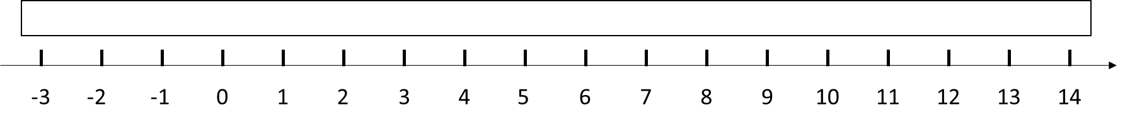

Ex 4: Ranges (2)

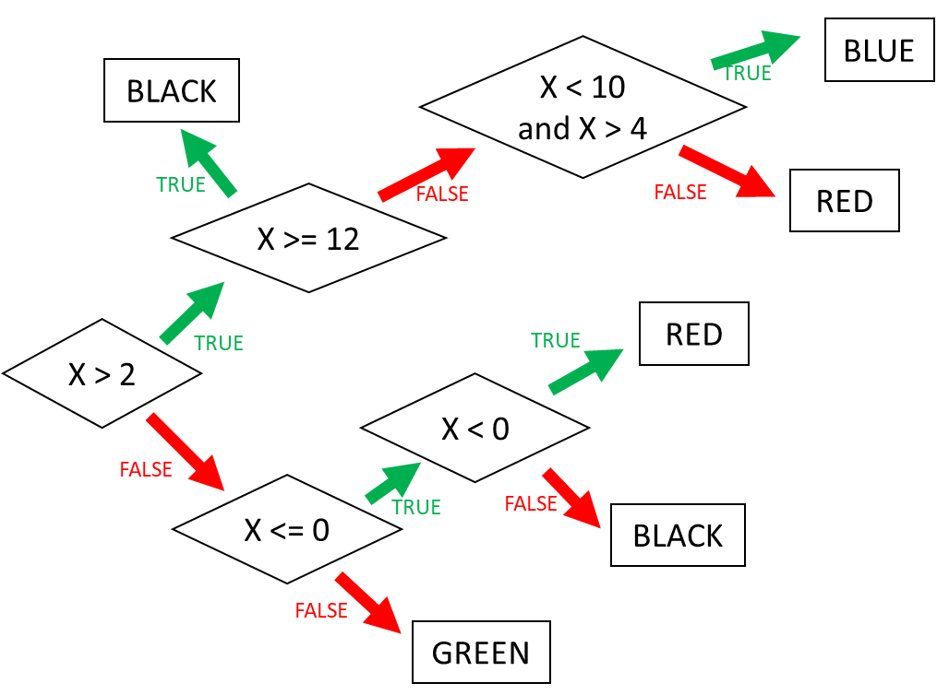



# 2D range colors

Example:

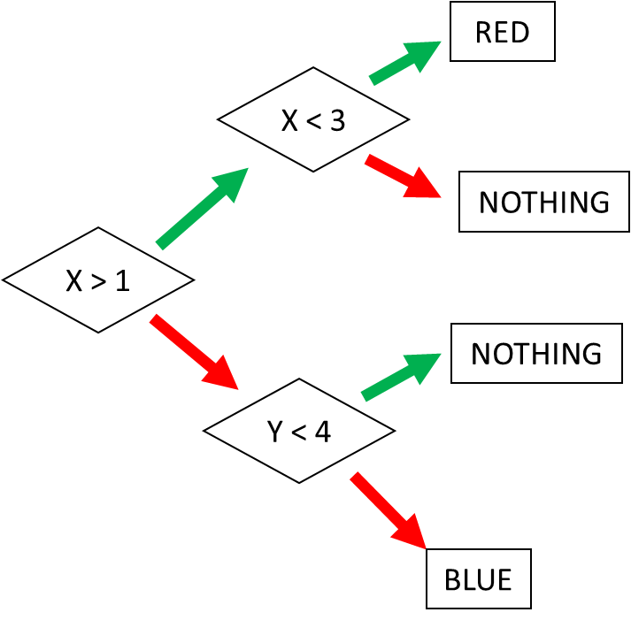 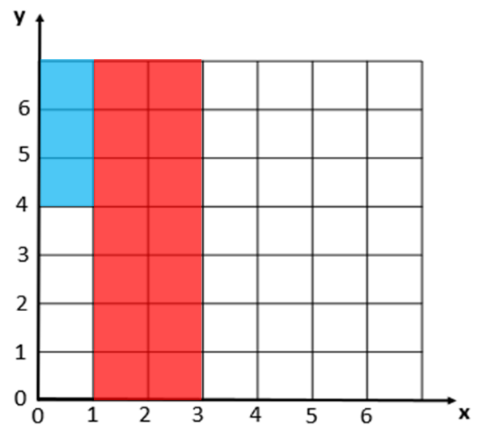

Ex 5: Square (1)

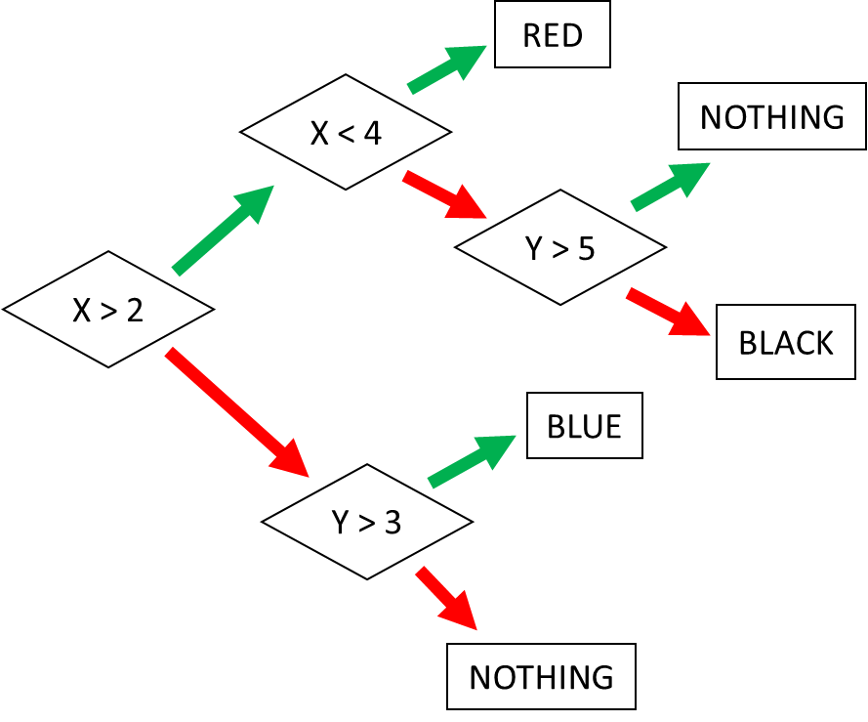 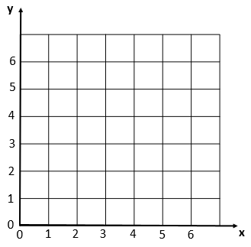

Ex 6: Square (2)

